Labwork: Identification of mountain iris based on logistic regression

Course: Artificial Intelligence
Student name: Fahim Shahriar Student No.: 202338070032
Completion date: 2026/06/01

1、 Experimental objectives
Through this experiment, based on the logistic regression model, the classification and discrimination of iris flowers are carried out, achieving the ability to solve recognition and classification problems using the logistic regression method.
2、 Experimental requirements
According to the principles of logistic regression and classification, fit the data and classify iris flowers, record the recognition results, draw conclusions, and write experimental reports.
3、 Experimental Principles
Logistic regression is a statistical model used for binary classification problems. Unlike linear regression, which predicts continuous values, logistic regression predicts the probability that a sample belongs to a particular class.
The core of logistic regression is the sigmoid function:
h(x) = 1 / (1 + e^(-z)) , where z = w₁x₁ + w₂x₂ + b
This function maps any real value to the interval (0,1), which can be interpreted as a probability.
The cost function (cross-entropy loss) measures how well the model predicts:
J(θ) = -1/m Σᵢ₌₁ᵐ [ y⁽ⁱ⁾ log(h(x⁽ⁱ⁾)) + (1 - y⁽ⁱ⁾) log(1 - h(x⁽ⁱ⁾)) ]
Gradient descent iteratively updates parameters to minimize this cost:
θⱼ := θⱼ - α (∂J/∂θⱼ)
where α (alpha) is the learning rate.
For probability modeling with bounded outcomes (0 to 1), logistic regression is more appropriate than linear regression.
4、 Experimental content
(1) Fitting an Example of Logistic Regression
Model the relationship between the proportion of problems encountered in vehicle mileage testing and the vehicle mass (in kg). Observations include vehicle mass, number of vehicles, and number of damages. The original data is shown in the table below:
Weights | 2100 | 2300 | 2500 | 2700 | 2900 | 3100 | 3300 | 3500 | 3700 | 3900 | 4100 | 4300
Vehicle number | 48 | 42 | 31 | 34 | 31 | 21 | 23 | 23 | 21 | 16 | 17 | 21
Failure number | 1 | 2 | 0 | 3 | 8 | 8 | 14 | 17 | 19 | 15 | 17 | 21

Write MATLAB program:
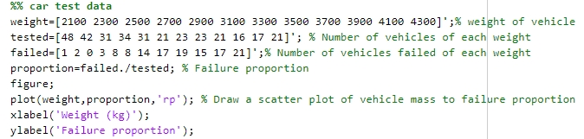
The program output result is shown in the figure:
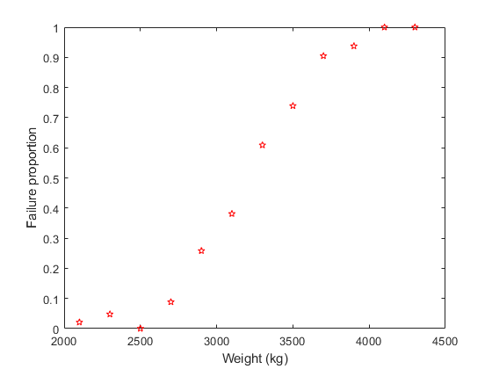
a. Use the fitting function polyfit(weight,proportion,1) to obtain the linear fitting result, draw the fitting curve, and write the linear model.

1) Write MATLAB program:
%% car test data
weight = [2100 2300 2500 2700 2900 3100 3300 3500 3700 3900 4100 4300];
tested = [48 42 31 34 31 21 23 23 21 16 17 21];
failed = [1 2 0 3 8 8 14 17 19 15 17 21];

proportion = failed ./ tested;

figure;
plot(weight, proportion, 'rp');
title(['Linear Fitting'])
xlabel('Weight (kg)');
ylabel('Failure proportion');

p = polyfit(weight, proportion, 1);
w = p(1);
b = p(2);

x = 2100:10:4300;
y = w * x + b;

hold on;
plot(x, y, 'b');

fprintf('y = %.6fx + %.6f\n', w, b);

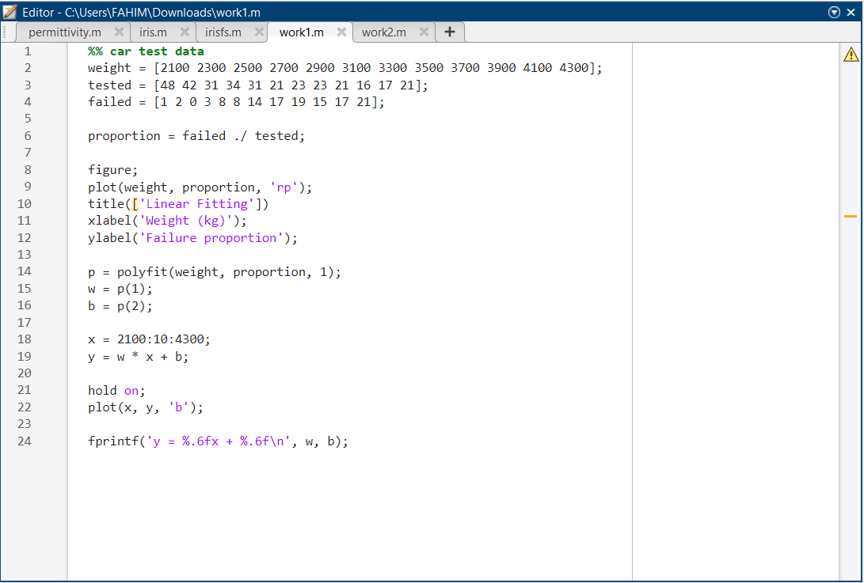

2) Program output result graph:
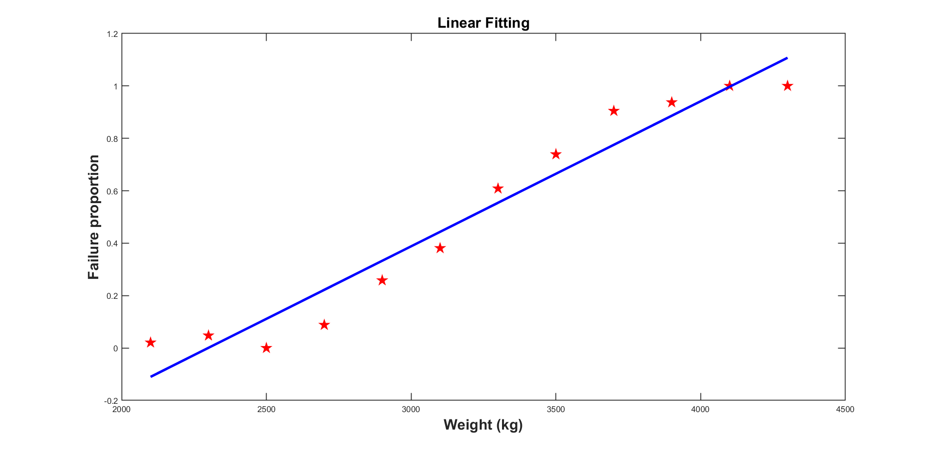

3) Regression model:
y = 0.000553x + -1.272280

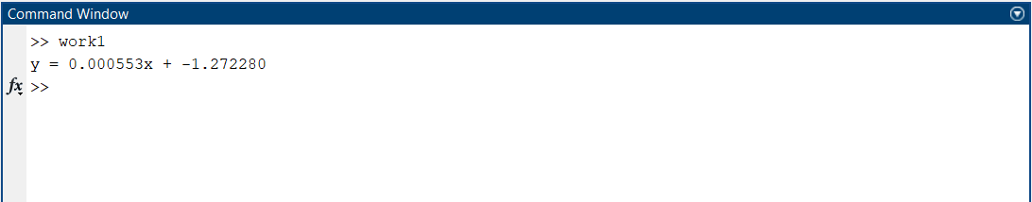

b. Use the fitting function glmfit(weight,[failed,tested],‘binomial’,‘logit’) to obtain the Logistic fitting results, draw the fitting curve, and write the Logistic regression model .

1) Write MATLAB program:
%% car test data
weight = [2100 2300 2500 2700 2900 3100 3300 3500 3700 3900 4100 4300]';
tested = [48 42 31 34 31 21 23 23 21 16 17 21]';
failed = [1 2 0 3 8 8 14 17 19 15 17 21]';

proportion = failed ./ tested;

figure;
plot(weight, proportion, 'rp');
title(['Linear Fitting'])
xlabel('Weight (kg)');
ylabel('Failure proportion');

b = glmfit(weight, [failed tested], 'binomial', 'link', 'logit');

x = (2100:10:4300)';
y = 1 ./ (1 + exp(-(b(1) + b(2) * x)));

hold on;
plot(x, y, 'b');

fprintf('Logistic regression model:\n');
fprintf('y = 1 / (1 + exp(-(%f + %f*x)))\n', b(1), b(2));

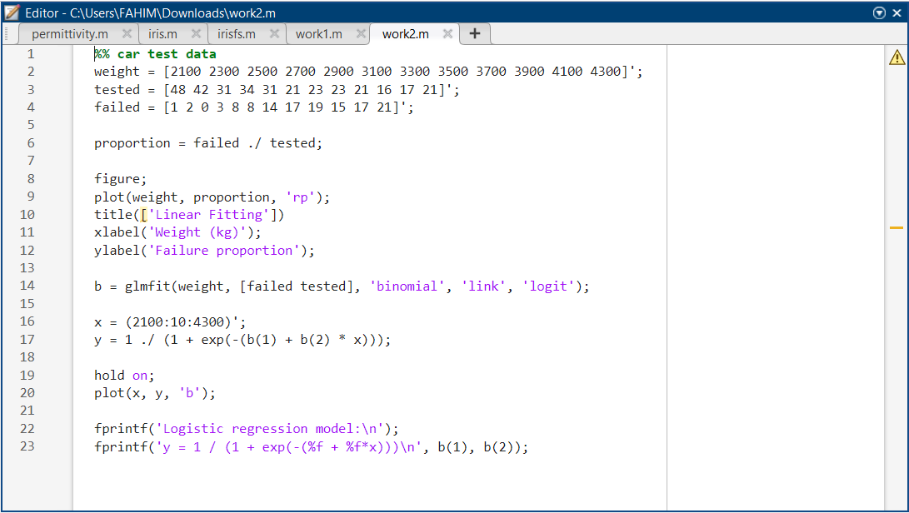

2) Program output result graph:
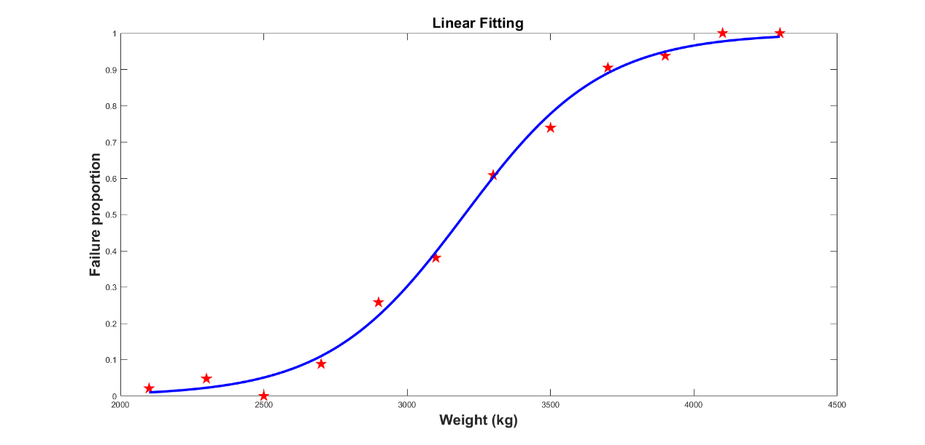

3) Regression model:
y = 1 / (1 + exp(-(-13.380147 + 0.004181*x)))
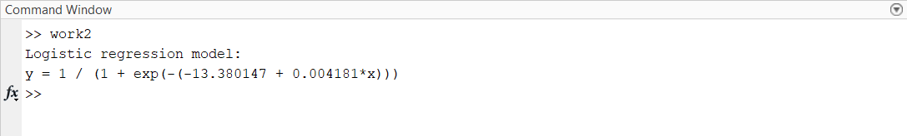

(2) Logistic regression for binary classification task
Use the Iris Data Set, which comes with the MATLAB system. In this dataset, three different types of Iris plants are included: setosa (mountain iris), versicolor (variegated iris), and virginica (Virginia iris).
Each category collected 50 samples, so this dataset contains a total of 150 samples. This dataset measures four attributes for all 150 samples, namely: sepal length, sepal width, petal length, and petal width. The unit of these four attributes is centimeters (cm). The dataset is named fisheriris.mat in the MATLAB system, where the variable meas is a 150 × 4 matrix, with each row representing a sample and each column representing an attribute of the sample. The variable species is a 150 dimensional vector that stores the labels of 150 samples (i.e. setosa, versicolor, and virginica categories). (Complete data can be found in Iris_Data.xlsx)
Since we only study the binary classification problem this time, we only select the first 100 samples of the dataset (data can be found in Iris_Data_binary.xlsx).
Our task is to establish a logistic regression classifier that predicts whether the label of the sample is Mountain Iris "1" or Colored Iris "0" based on the two characteristic values of the sample's sepal length , and sepal width . Draw the separation curve, plot the evolution curve of the cost function with the number of iterations, and provide the values of the parameters .

Main Reminder:
--Pay attention to the normalization of eigenvalues, and use the min-max normalization method to map the sum of two eigenvalues and to the [0,1] interval
--The number of iterations is set to 10000, the learning rate is set to 0.2, and the initial parameter value is 0
--The projection line of the plane on plane is, which is the separation curve
--Codes reference: https://www.cnblogs.com/hyb965149985/p/10601418.html
1) Write MATLAB program:
%% %% 数据准备 (Data Preparation)
% 1. Load feature data
load('Iris_Data.mat');
data = IrisData;

% 2. Load binary label data
load('Iris_Data_binary.mat');
label = IrisDatabinary;

% 3. Convert tables to numeric matrices
data_matrix = table2array(data(:, 1:4));

% IMPORTANT:
% IrisDatabinary has 3 columns:
% column 1 = sepal length
% column 2 = sepal width
% column 3 = binary label
label_matrix = table2array(label(:, 3));

% 4. Match feature rows with label rows
num_samples = size(label_matrix, 1);
data_matrix = data_matrix(1:num_samples, :);

% 5. Use only first two features
data_features = data_matrix(:, 1:2);

%% %% Min-Max Normalization
data_norm = (data_features - min(data_features)) ./ ...
(max(data_features) - min(data_features));

%% %% Add Bias Term
data_ready = [data_norm, ones(size(data_norm, 1), 1)];

%% %% Shuffle Data
randIndex = randperm(num_samples);
data_new = data_ready(randIndex, :);
label_new = label_matrix(randIndex, :);

%% %% 80% Training 20% Testing
num_samples = size(data_new, 1);
k = round(0.8 * num_samples);

% Training Data
X1 = data_new(1:k, :);
Y1 = label_new(1:k, :);

% Testing Data
X2 = data_new(k+1:end, :);
Y2 = label_new(k+1:end, :);

[m1, n1] = size(X1);
[m2, n2] = size(X2);
Features = size(data_ready, 2);

%% %% 开始训练 (Start Training)
delta = 0.2; % Learning Rate
lamda = 0; % Regularization Coefficient

% Initial beta = 0
theta1 = zeros(1, Features);

%% %% Gradient Descent Training
num = 10000;
L = zeros(1, num);

for iter = 1:num
dt = zeros(1, Features);
loss = 0;

for i = 1:m1
xx = X1(i, 1:Features);
yy = Y1(i, 1);

% Sigmoid Function
h = 1 / (1 + exp(-(theta1 * xx')));

% Avoid log(0)
h = max(min(h, 1 - 1e-15), 1e-15);

% Gradient
dt = dt + (h - yy) * xx;

% Loss Function
loss = loss + yy * log(h) + (1 - yy) * log(1 - h);
end

% Average Loss
loss = -loss / m1;
L(iter) = loss;

% Parameter Update
theta1 = theta1 - delta * dt / m1 - lamda * theta1 / m1;
end

%% %% Draw Figures
figure

%% %% Cost Function Curve
subplot(1, 2, 1)
plot(L, 'LineWidth', 2)
xlabel('Iteration')
ylabel('Loss')
title('Cost Function')
grid on

%% %% Logistic Regression Separation Curve
subplot(1, 2, 2)
hold on

% Draw Class 1 points
idx1 = find(label_matrix == 1);
plot(data_norm(idx1, 1), data_norm(idx1, 2), 'ro', ...
'MarkerFaceColor', 'r', 'MarkerSize', 5)

% Draw Class 0 points
idx0 = find(label_matrix == 0);
plot(data_norm(idx0, 1), data_norm(idx0, 2), 'go', ...
'MarkerFaceColor', 'g', 'MarkerSize', 5)

% Separation boundary:
% w1 * SepalLength + w2 * SepalWidth + b = 0
x = 0:0.01:1;
y = (-theta1(1) * x - theta1(3)) / theta1(2);
plot(x, y, 'k', 'LineWidth', 2)

xlabel('Normalized Sepal Length')
ylabel('Normalized Sepal Width')
title('Logistic Regression Boundary: Sepal Length vs Sepal Width')

legend('Setosa / Mountain Iris (1)', ...
'Versicolor / Colorful Iris (0)', ...
'Separation Boundary', ...
'Location', 'best')

axis([-0.05 1.05 -0.05 1.05])
grid on
hold off

%% %% Testing Accuracy
acc = 0;

for i = 1:m2
xx = X2(i, 1:Features)';
yy = Y2(i);

final = 1 / (1 + exp(-theta1 * xx));

if final > 0.5 && yy == 1
acc = acc + 1;
end

if final <= 0.5 && yy == 0
acc = acc + 1;
end
end

accuracy = acc / m2 * 100;
fprintf('Accuracy = %.2f%%\n', accuracy);

%% %% Print Parameters
fprintf('w1 = %.8f\n', theta1(1));
fprintf('w2 = %.8f\n', theta1(2));
fprintf('b = %.8f\n', theta1(3));
fprintf('Final loss = %.8f\n', L(end));

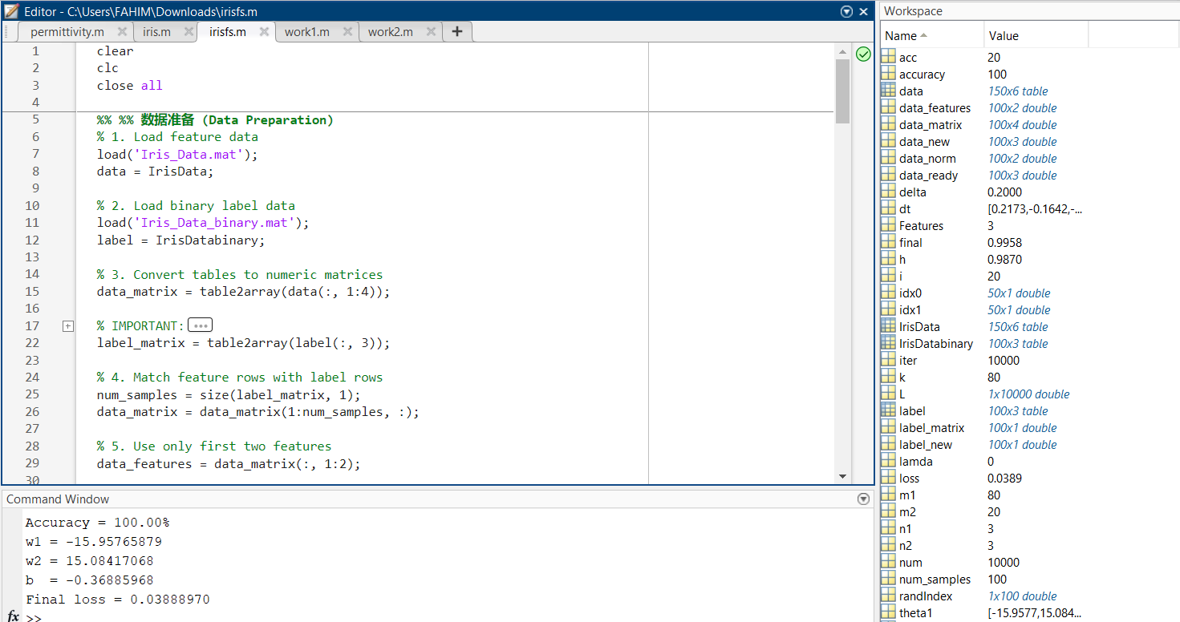

2) Program output result graph:
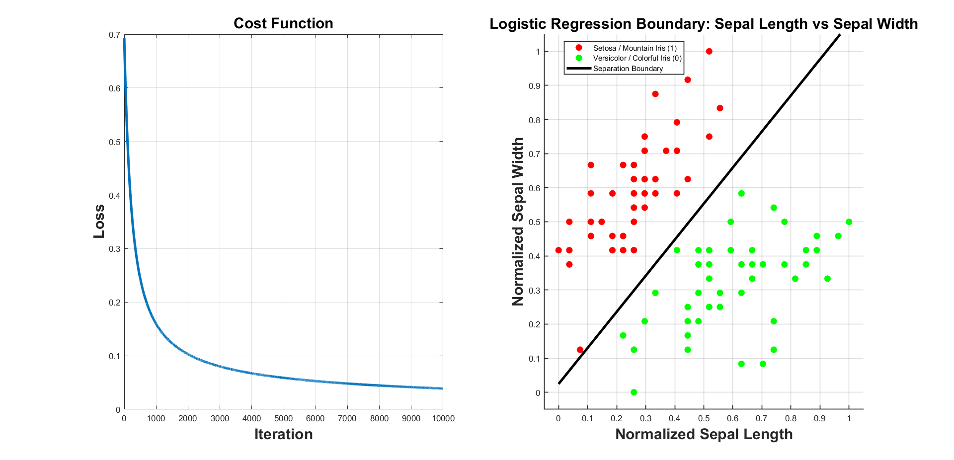

3) Parameters:

Accuracy = 100.00%
w1 = -15.95765879
w2 = 15.08417068
b = -0.36885968
Final loss = 0.03888970

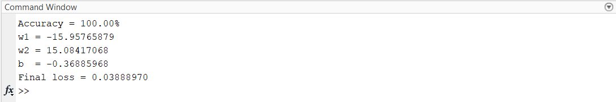

6、 Discussion and conclusion:





